SOFTWARE ENGINEERING THEORY PROJECT  
USER’S MANUAL



**Fall Semester 2016-2017**

**TOPIC:**

Restaurant Service System



**Teacher:**

Prof. Alok Chauhan

**STUDENTS:**

* Osho Agyeya(15BCE1326)
* Kashish Miglani(15BCE1003)
* Sanchay Gupta(15BCE1190)
* Sachin Gopal(15BCE1188)

**MANUAL**

INTRODUCTION:

Product rational and overview:

Restaurant service system has become a successful answer for efficient ordering in the fooding sector. Not only does it provide the convenience of ordering food from restaurants while sitting at home, it also helps the owner or the admin of the website to maintain a clean database of orders given. This generates efficiency in food resource planning while reducing the workload of both the admin and the customer. Online food ordering is a process of ordering food from a local restaurant or food cooperative through a web page or app. Much like ordering consumer goods online, many of these allow customers to keep accounts with them in order to make frequent ordering convenient. A customer will search for a favourite restaurant, usually filtered via type of cuisine and choose from available items, and choose delivery or pick-up. Payment can be amongst others either by credit card or cash, with the restaurant returning a percentage to the online food company.

TERMINOLOGY USED:

The basic terminology that will be followed during the entire software manual is given as follows:

## A

**Acceptance criteria**: The exit criteria that a component or system must satisfy in order to be accepted by a user, customer.

**Accuracy**: The capability of the software product to provide the right or agreed results or effects with the needed degree of precision

**Adaptability:** The capability of the software product to be adapted for different specified environments without applying actions or means other than those provided for this purpose for the software considered

**Assessment:** Activity of determination of quantitative or qualitative value of a product, service, activity, process in regard to given quality or acceptance criteria.

**Attractiveness**: The capability of the software product to be attractive to the user .

**Attribute**: A characteristic of an object.

**Availability:** The degree to which a component or system is operational and accessible when required for use.

## B

**Baseline:** A specification or software product that has been formally reviewed or agreed upon, that thereafter serves as the basis for further development, and that can be changed only through a formal change control process

**Benefit**: Value delivered to stakeholders

## C

**Changeability:** The capability of the software product to enable specified modifications to be implemented.

**Component:** A minimal software item that e.g. can be tested in isolation.

**Consistency:** The degree of uniformity, standardization, and freedom from contradiction among the documents or parts of a component or system.

**Constraint**: A statement of restriction that modifies a requirement or set of requirements by limiting the range of acceptable solutions

**Customer:** Current or potential buyer or user of the products or service of an individual or organization, called the supplier, seller, or vendor

## D

**Defect:** A flaw in a component or system that can cause the component or system to fail to perform its required function, e.g. an incorrect statement or data definition. A defect, if encountered during execution, may cause a failure of the component or system.

## E

**Efficiency:** The capability of the software product to provide appropriate performance, relative to the amount of resources used under stated conditions

**Error*:*** A human action that produces an incorrect result

## F

**Failure:** Deviation of the component or system from its expected delivery, service or result.

**Feature:** An attribute of a component or system specified or implied by requirements documentation (for example reliability, usability or design constraints)

**Function:** A description of “what” a system does.

**Functional requirement:** A requirement that specifies a function that a component or system must perform.

## G

**Goal:** A desired state or result of an undertaken. Goals should be measurable and defined in time so that the progress can be monitored.

## H

**High-level:** A position in a hierarchy of defined system components, which is closer to the top than the bottom, relative to the total defined set of those components

## I

**Impact:** Estimated or actual numeric effect of a design idea on a requirement attribute under given conditions.

## L

**Learnability:** The capability of the software product to enable the user to learn its application

## M

**Maintainability:** The ease with which a software product can be modified to correct defects, modified to meet new requirements, modified to make future maintenance easier, or adapted to a changed environment .

**Measure:** The number or category assigned to an attribute of an entity by making a measurement.

## N

**Need:** Something desired by a defined stakeholder. Satisfying that need would have some value for some stakeholder. A need might not be agreed as a formal requirement, and it might not be prioritized such that it is actually acted upon (designed and implemented). Need is a term often used as a stakeholder view of a problem before requirements specification is carried out .

**Non-functional requirement:** A requirement that does not relate to functionality, but to attributes such as reliability, efficiency, usability, maintainability and portability.

## O

**Operability:** The capability of the software product to enable the user to operate and control it.

## P

**Performance:** The degree to which a system or component accomplishes its designated functions within given constraints regarding processing time and throughput

**Point of view**: A certain perspective on the system or requirements.

**Portability:** The ease with which the software product can be transferred from one hardware or software environment to another

**Priority:** The level of (business) importance assigned to an item.

**Process:** A set of interrelated activities, which transform inputs into outputs .

**Product:** An output of a process.

**Product requirement**: A requirement related to the product of the development process. They affect quality of the product.

## Q

**Quality Assurance (QA):** Part of quality management focused on providing confidence that quality requirements will be fulfilled

## R

**Reliability:** The ability of the software product to perform its required functions under stated conditions for a specified period of time, or for a specified number of operations.

**Requirement**: (1) A condition or capability needed by a user to solve a problem or achieve an objective. (2) A condition or capability that must be met or possessed by a system or system component to satisfy a contract, standard, specification, or other formally imposed documents. (3) A documented representation of a condition or capability as in (1) or (2) .

**Requirements analysis**: A set of tasks, activities and tools to determine whether the stated (elicited) requirements are unclear, incomplete, ambiguous, or contradictory, and then documenting the requirements in a form of consistent model.

**Review:** An evaluation of a product or project status to ascertain discrepancies from planned results and to recommend improvements. Examples include management review, informal review, technical review, inspection, and walkthrough .

**Risk:** (1) The effect of uncertainty on objectives, whether positive or negative (2) A factor that could result in future negative consequences; usually expressed as impact and likelihood.)

## S

**Safety:** The capability of the software product to achieve acceptable levels of risk of harm to people, business, software, property or the environment in a specified context of use .

**Scalability:** The capability of the software product to be upgraded to accommodate increased loads

**Scenario**: (1) A projected course of action, events or situations leading to specified result. (2) An ordered sequence of interactions between specified entities (e.g. a system and an actor). (3) In UML: an execution trace of a use case.

**Scope**: The extent of influence of something. Scope can apply to anything, like a specification, or a specified system or project

**Security:** Attributes of software products that bear on its ability to prevent unauthorized access, whether accidental or deliberate, to programs and data [ISO/IEC 25000]. See also *Functionality.*

**Software quality:** The totality of functionality and features of a software product that bear on its ability to satisfy stated or implied needs.

**Solution:** (1) Solution is the implementation of the requirement. (2) A design idea which, if implemented, is expected to lead to the partial or full satisfaction of a set of attribute requirements; to solve a (defined) problem.

**Specification:** A document that specifies, ideally in a complete, precise and verifiable manner, the requirements, design, behaviour, or other characteristics of a component or system, and, often, the procedures for determining whether these provisions have been satisfied.

**Stability:** The capability of the software product to avoid unexpected effects from modifications in the software

**Stakeholder:** Any person who has an interest in an IT project. Project stakeholders are individuals and organizations that are actively involved in the project, or whose interests may be affected as a result of project execution or project completion.

**Standard:** Formal, possibly mandatory, set of requirements developed and used to prescribe consistent approaches to the way of working or to provide guidelines

**System:** A collection of components organized to accomplish a specific function or set of functions.

## T

**Testability:** The capability of the software product to enable modified software to be tested.

**Testable requirements:** The degree to which a requirement is stated in terms that permit establishment of test designs (and subsequently test cases) and execution of tests to determine whether the requirements have been met.

**Traceability:** The ability to identify related items in documentation and software, such as requirements with associated tests.

## U

**Understandability:** The capability of the software product to enable the user to understand whether the software is suitable, and how it can be used for particular tasks and conditions of use

**Usability:** The capability of the software to be understood, learned, used and attractive to the user when used under specified conditions

**User**: A person who uses a software product.

## V

**Value:** Perceived benefit , it is the potential consequence of system attributes, for one or more stakeholders. Value is the perceived usefulness, worth, utility, or importance of a defined system component or system state, for defined stakeholders, under specified conditions. Value is relative to a stakeholder: it is not absolute.

**Vendor**: A person, group or organization providing the solution.

**Verification:** Confirmation by examination and through provision of objective evidence that specified requirements have been fulfilled

**Version:** A specific form or variation of something.

**Vision:** An image of the project's deliverable as the solution to the stated need or problem.

## W

**Walkthrough:** A step-by-step presentation by the author of a document in order to gather information and to establish a common understanding of its content.

BASIC FEATURES:

SIGNUP: This feature enables new customers/admin to create their accounts.

LOGIN: This feature enables existing customers/admin to enter into their accounts.

RESTAURANT MENU: The entire restaurant food menu details have been displayed in the website along with dish type and their prices.

PLACE ORDER: The user is entitled to place his order according to his wishes along with the subsequent bill generation.

VIEW DETAILS (ORDER): This feature enables existing customers to view all the orders that had been submitted by them.

ORDER VIEW/APPROVAL: The admin is allowed to view the orders and approve them according to whether he has the time and necessary resources in order to prepare that order not.

DELIVERY OPTIONS: The customer has been given the option of choosing to whether he wants to dine at the restaurant itself, take the packed meal from the restaurant as a pickup or get the packed meal delivered to his home.

EDIT DETAILS : This feature enables existing customers to edit all the details that they had provided at the time of sign up.

SUMMARY OF DISPLAY AND REPORT FORMATS:

The format of the manual is in accordance with the conventional manual format used by major agencies. It can be described as follows:

Text written in this font style is indicative of the main headings that have been used in the manual.

Text written in this font style is indicative of the sub headings that have been used inside the main headings the manual.

Text written in this font style is indicative of the various points that have been listed inside the sub headings the manual.

A single page break has been provided after every sub heading and its description is complete.

A double page break has been provided after every main heading and its description is complete.

Text written in **bold** has been used for major emphasis as well as occasional headings.

Text which has beenunderlined has been used for mentioning key points.

OUTLINE OF THE MANUAL:

The outline of the manual serves the purpose of explaining in simple terminology the entire manual in brief. It is equivalent to just touching the points listed in the manual.

* Introduction

1. Product rationale and overview: This section focuses on the basic purpose of the software product. A brief idea about the need of product, its basic functionalities and its advantages is mentioned. This is intended to give a general overview of the product aimed at acquainting the user with the software product.
2. Terminology: This section is dedicated to mentioning all the possible terms that might be used in this manual . The official definition of the terms has been mentioned which can be used as a reference hereafter.
3. Basic features: This section describes the basic functionalities which the application provides for execution.
4. Summary of display and report formats: The summary of display and report format is aimed at briefing the reader about the format in which the manual has been written. It includes the order that is followed during the entire
5. Outline of the manual: This section brushes up with all the topics that have been covered while writing the manual . It is just a simple coverage of all the headings that have been covered in this manual.

* Getting started

1. Sign on: Single sign-on (SSO) is a session and user authentication service that permits a user to use one set of login credentials (e.g., name and password) to access multiple applications. The service authenticates the end user for all the applications the user has been given rights to and eliminates further prompts when the user switches applications during the same session. On the back end, SSO is helpful for logging user activities as well as monitoring user accounts.
2. Help mode: The help mode is needed when the user has doubts regarding the options that are available for implementation. This can be helpful when the user wants to dynamically learn from the help section.
3. Sample run: This section contains screenshots of the software implementation. This helps the user to check his implementation view with the actual implementation

* Modes of operation

1. Commands/displays/options-This is aimed at showcasing the various options that are available to the user.

* Advanced features-This states the special features available for certain peculiar tweaks.
* Command syntax and system options-Syntax and settings options for the application.

GETTING STARTED:

SIGN ON:

The account creation is a necessary activity in order to access the website. At the time of account creation, the user needs to provide his username, email id, and phone no, password, address and hint questions in order to create a customer account. In the same way, the admin needs to provide his email and password initially to create an account. Once the accounts have been created, the Single sign-On(SSO) property is exhibited ,that is the user can use the credentials provided by him in order to sign in on multiple machines (one at a time). As a result, a single email id and password are sufficient for a user to access his account.

HELP MODE:

The help mode is an important segment of this manual. This is mainly used for reference by the user in case of any contingency.

* **Forget password condition**: In case the user forgets his password, then he is given the option of entering the answer of two questions that he had mentioned at the time of signup. If the user gives the correct option then he/she is reminded of his password.
* **Reset password:** In case the user feels that the password chosen by him is inadequate, then he/she can change his password by choosing the option that has been provided.
* **Cancel order:** In case the user feels that the order provided by him can be edited or needs appending, then the user can cancel the present order and upload his new order.
* **Order not sent:** In case the order is not sent to the admin or the order processing stage encounters an error, then the user can resend the order without having to mention the order again and again.
* **Order approval not sent**: In case the order is not approved by the admin or the order approving stage encounters an error, then the admin can resend the order approval.
* **Order item confusion:** The names of the dishes have been made available in the most simple language as possible. If any confusion persists, then the customer can find the relevant information about the dish online simultaneously.
* **Bill calculation:** The script for calculating the price has been made with utmost accuracy. In case the final amount has some calculation error, then the order can be cancelled and mentioned again.

SAMPLE RUN :

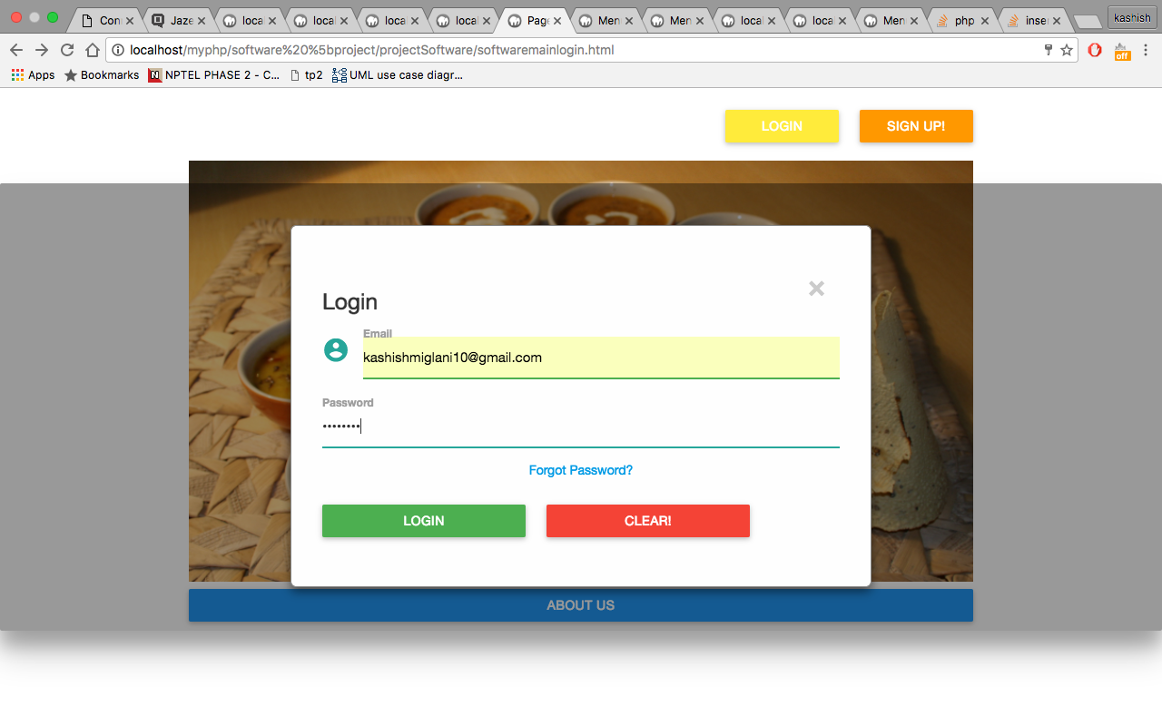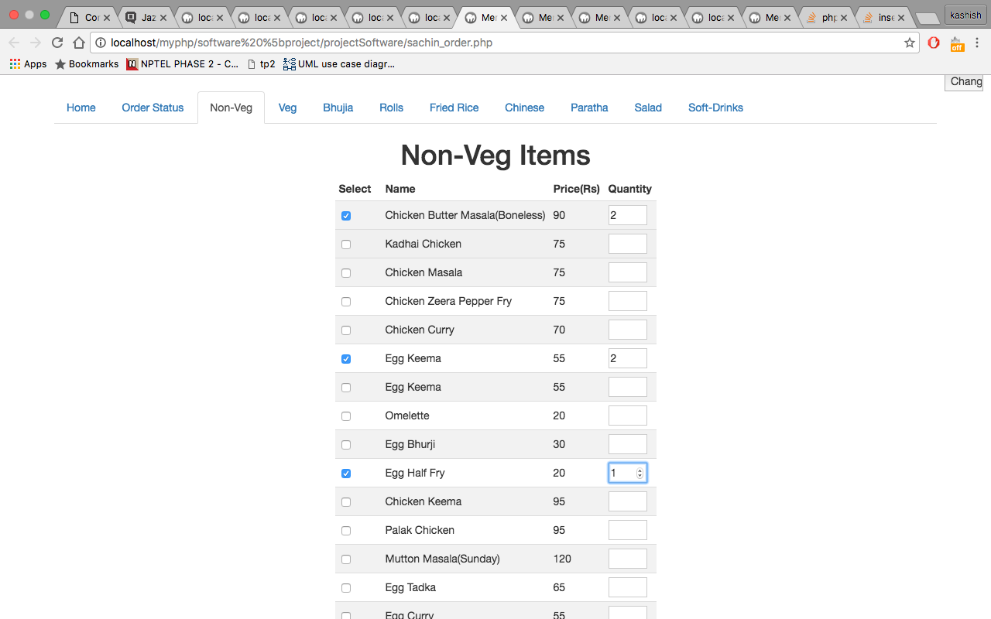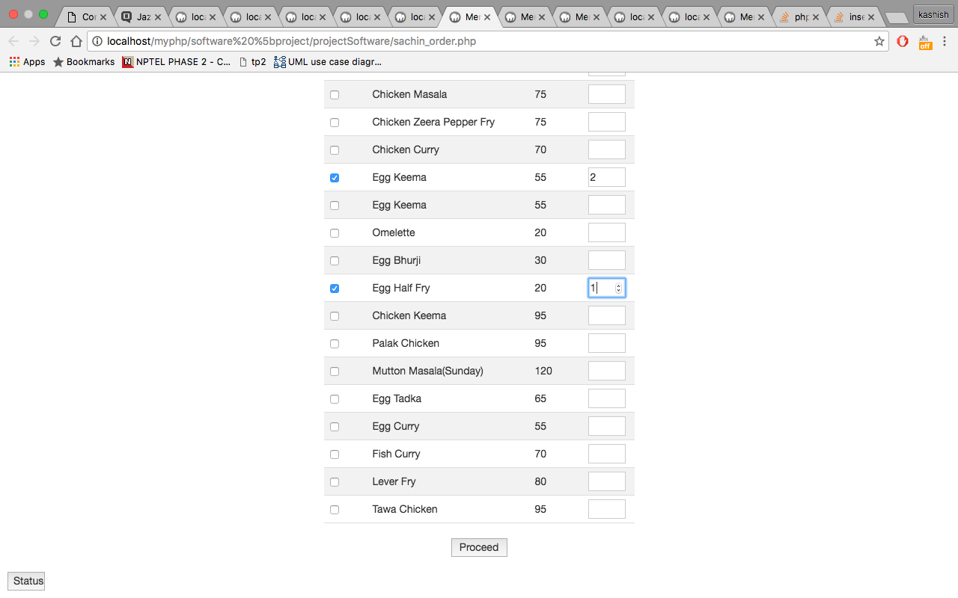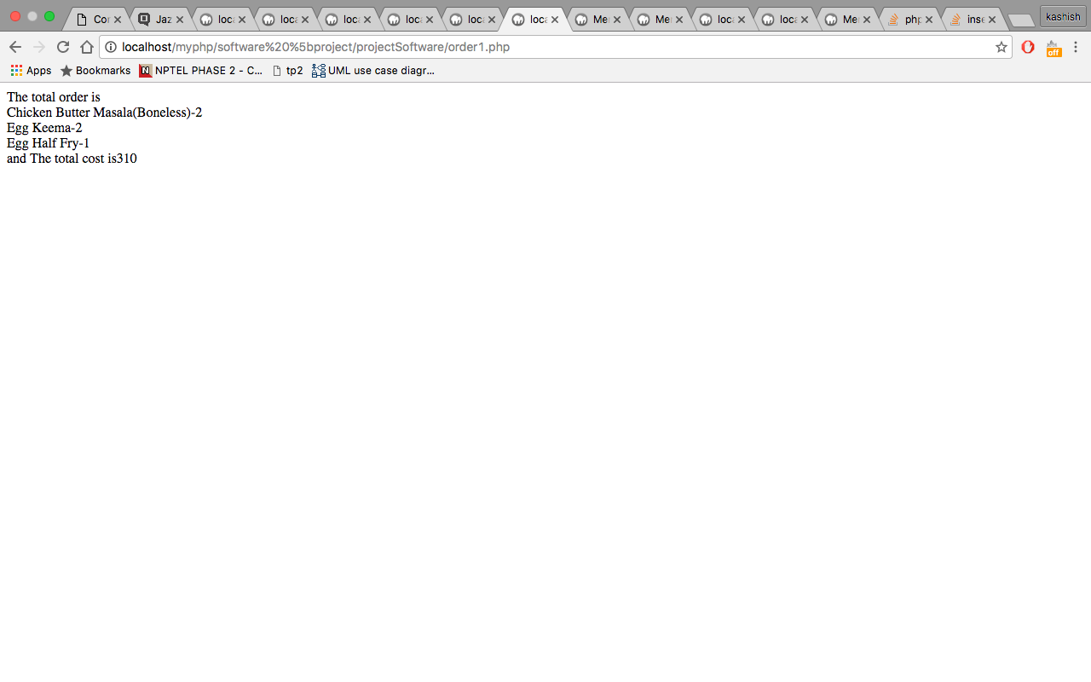

MODES OF OPERATION:

Commands/displays/options

The website adheres to conventional browser commands and shortcuts like refresh and return back to the previous page. The display works on varying display sizes and browsers normally. The website is optimized for an enhanced user experience without any difficulty in the process. The customer’s order is saved for a short period of time, even after closing the browser to speed-up the checkout process. The customer can cancel the order in case of any changes in plans and subsequent changes are reflected in the restaurant manager’s display.

The menu is designed in a simple, easy to use manner which is intuitive. It is categorized by type for easy navigation. After placing the order, the customer can view the status of the order which is managed by the restaurant’s manager.

The restaurant manager can view all the orders placed in the restaurant in an easy to view, serialized fashion. The manager can accept or reject the orders based on availability and the customer can be informed of the same immediately. Finance management becomes easy through the total bill calculator.

Advanced Features:

The website provides advanced features for enhanced user experience. These advanced options need not be necessarily employed by the user but act as optional features.

VIEW DETAILS (ORDER): This feature enables existing customers to view all the orders that had been submitted by them.

ORDER VIEW/APPROVAL: The admin is allowed to view the orders and approve them according to whether he has the time and necessary resources in order to prepare that order not.

EDIT DETAILS: This feature enables existing customers to edit all the details that they had provided at the time of sign up.

Command Syntax and System Options

Since the system is GUI based, there is no defined syntax that the user has to follow while giving instructions to the application. The basic structure of the application can be changed only by altering the very source code (php,html,javascript) of the application.